

Executive Summary
This business intelligence analysis evaluates an online home-retail transaction dataset containing 541,909 transaction records, supported by three Power BI dashboard views covering:
- Customer retention and repeat purchasing
- Revenue and sales performance
- Product and category performance
- Geographic revenue distribution
- Monthly sales trends
- Top-performing products
The analysis identifies a strong repeat-customer contribution to business revenue. Out of 8,082 customers, 3,059 are repeat customers, giving a 37.85% repeat-customer rate.
- The most significant finding is that repeat customers contribute approximately 78.27% of total revenue, demonstrating that customer retention and purchase frequency are much more important revenue drivers than simply acquiring new customers.
- The business generated approximately ₹11.59 million in sales across 25,900 orders, resulting in an average order value of approximately ₹447.32 and average revenue per customer of approximately ₹1,433.51.
- Sales are highly seasonal. The second half of the year generated approximately ₹7.23 million, compared with ₹4.36 million in the first half, representing a 65.94% increase. December was the strongest month with approximately ₹1.74 million in revenue.
- Geographically, the United Kingdom dominates the business, accounting for approximately 85.13% of total revenue. At product level, the Kitchen Drawer Organizer is the highest-revenue product, while the Soap Dispenser Set is the highest-volume product.

Dataset Statistics
Metric | Result
Transaction lines | 541,909
Unique customers | 8,082
Orders / invoices | 25,900
Revenue | ₹11,585,621.15
Repeat customers | 3,059
Repeat customer rate | 37.85%
Average order value | ₹447.32
Average revenue/customer | ₹1,433.51
Product/SKU codes | 375

The dataset covers monthly activity from January through December, with the dashboard providing year selection for 2010 and 2011.
Overall, the analysis indicates that the business should prioritize:
- Customer retention and second-purchase conversion
- Strong inventory and marketing preparation for the September–December peak
- Cross-selling and product bundling
- Gradual international market expansion
Dataset Overview
The supplied Excel workbook contains two sheets:
- Raw Data
- Cleaned Data

The cleaned dataset contains additional analytical fields such as:
- Invoice Year
- Invoice Month
- Total Invoice Amount
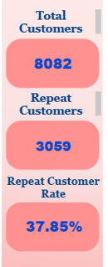
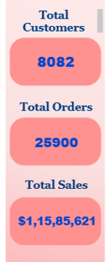
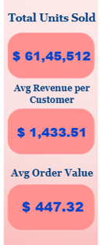
- Overall KPI Performance

KPI | Value | Interpretation
Total Customers | 8,082 | Strong identifiable customer base
Repeat Customers | 3,059 | Significant retained customer segment
Repeat Customer Rate | 37.85% | Approximately 4 in 10 customers purchase repeatedly
Total Orders | 25,900 | Strong transaction activity
Total Sales | ₹11.59M | Overall revenue generated
Average Order Value | ₹447.32 | Benchmark for basket-building strategies
Average Revenue/Customer | ₹1,433.51 | Overall customer value
Repeat Customer Revenue Share | 78.27% | Retention customers drive the majority of revenue

Customer Retention Analysis
  - Repeat Customer Rate
A repeat customer is defined as a customer who has placed more than one distinct order/invoice.
The analysis produces:
- Total customers = 8,082
- Repeat customers = 3,059
- One-time customers = 5,023
- Repeat customer rate = 37.85%

Therefore:
62.15% of customers are currently one-time customers.
This represents the largest untapped customer opportunity in the dataset.
  - Repeat Customers Are the Main Revenue Engine
Repeat customers generated approximately:
₹9.07 million
This represents:
78.27% of total revenue
Despite representing only:
37.85% of customers
This indicates a substantial difference between the value of retained and one-time customers.
Average Revenue Per Customer
Repeat customer average revenue:
≈ ₹2,964 per customer

One-time customer average revenue:
≈ ₹501 per customer
Therefore, a repeat customer generates approximately 5.9× the revenue of a one-time customer on average.
This is one of the most important findings from the analysis.
Business Meaning
The business does not necessarily need to rely entirely on acquiring more customers.
Increasing the percentage of existing customers who make a second or third purchase could produce significant revenue growth.

Monthwise Repeat Customer Analysis
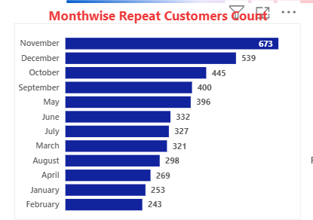

Key Findings
November is the strongest month for repeat customers with 673, followed by:
- December – 539
- October – 445
- September – 400
The period from September to December shows a clear increase in repeat purchasing.
This likely reflects:
- Festive shopping
- Promotional campaigns
- Gifting
- Seasonal home purchases
- Increased shopping frequency
- Year-end demand
The weakest month is February, with only 243 repeat customers.

Business Opportunity
January and February should be treated as strategic retention months.
Possible campaigns include:
- Second-purchase discounts
- Loyalty points
- Personalized recommendations
- Replenishment reminders
- "Complete your home" campaigns
- Category-based offers
- Post-festival re-engagement campaigns
Repeat Purchasing by Product Category
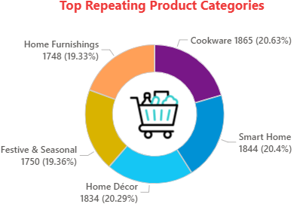
Interpretation
- Cookware is the strongest repeat-purchase category.
- Smart Home and Home Décor are also particularly strong.
- The relatively balanced distribution indicates that repeat purchasing is not dependent on one category.
This provides an opportunity to build category-specific loyalty journeys.

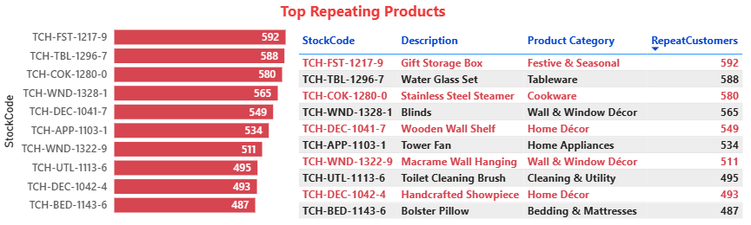
Top Repeating Products

The Gift Storage Box is the strongest repeating product.
The list contains a combination of:
- Seasonal products
- Kitchen products
- Home décor
- Bathroom products
- Home appliances
- Cleaning products
- Bedding
This demonstrates that repeat behaviour exists across both replenishment-driven and discretionary products.

Monthly Revenue Performance
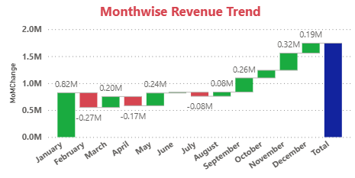
Revenue Seasonality
December is the highest-revenue month:
December Revenue
₹1.74M
November follows:
November Revenue
₹1.56M
The business shows a sustained acceleration beginning in September.
First Half vs Second Half
Period | Revenue
H1 | ₹4.36M
H2 | ₹7.23M
H2 Growth vs H1 | 65.94%
Approximately 62.4% of annual revenue is generated during H2.
Business Interpretation
This is a major planning signal.
Inventory, marketing, staffing, logistics and promotional budgets should not be evenly distributed across the year.
The business should prepare aggressively before September.
Geographic Revenue Analysis
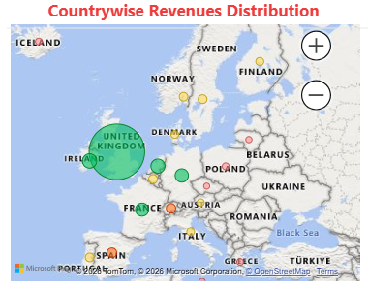
United Kingdom Dominance
The United Kingdom generates approximately: 85.13% of total revenue
This creates both an advantage and a risk.
Advantage
The business has a highly established core market.
Risk
The business has substantial geographic concentration.
A downturn in UK demand could therefore materially affect overall revenue.
International Expansion Opportunity
After the UK, the most promising visible markets include:
- EIRE
- Netherlands
- Germany
- France
- Australia
These markets currently contribute substantially less revenue than the UK.
Rather than aggressively expanding everywhere, the business should identify markets with:
- High repeat-purchase potential
- Strong average order value
- Favourable logistics economics
- Strong category demand
- Lower customer acquisition cost
A pilot-based international expansion strategy would be preferable.
Top Products by Revenue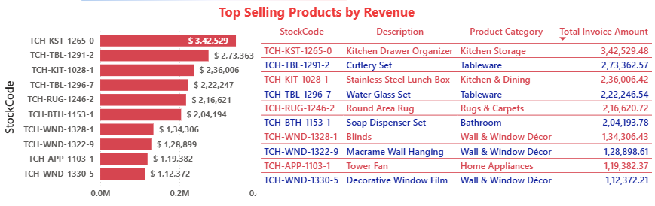
Leading Product
The Kitchen Drawer Organizer generates approximately: $342,529 , making it the highest-revenue SKU.
The top five products contribute approximately: 17.18% of total revenue
This indicates that revenue is reasonably diversified across the product portfolio.
Top Products by Units
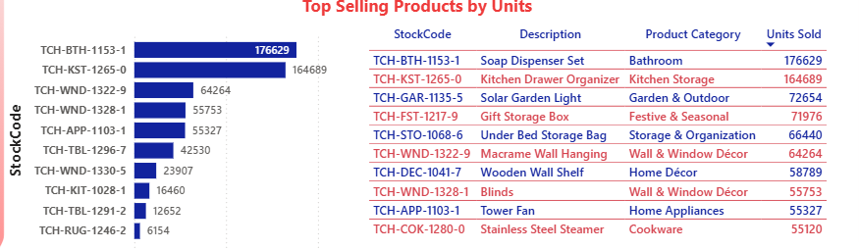
Important Observation
Revenue leadership and unit-volume leadership are not identical.
For example:
- Soap Dispenser Set → highest unit volume
- Kitchen Drawer Organizer → highest revenue
This means management should evaluate products using both:
Revenue + Units + Repeat Purchase Rate
rather than relying on one metric.
Major Business Insights
- Retention is the biggest growth opportunity
Only 37.85% of customers are repeat customers.
However, those customers generate 78.27% of revenue.
This means customer retention is considerably more valuable than the raw customer count suggests.
- The business is highly seasonal
September through December represents the strongest revenue period.
December alone produces approximately ₹1.74M.
The business should therefore prepare inventory and campaigns well before the peak season.
- The UK is the core market
Approximately 85.13% of revenue comes from the United Kingdom.
This provides a strong base but also creates geographic concentration risk.
- Functional home products perform strongly
Kitchen, bathroom, tableware, storage and décor products appear repeatedly among the leading revenue, unit and repeat-purchase products.
This suggests strong demand for practical and functional home products.

Dashboard Assessment
The Power BI dashboard is visually structured around three useful analytical perspectives:
Dashboard 1 — Sales & Geographic Analysis
Strong elements:
- Total customers
- Total orders
- Total sales
- Monthly sales
- Country revenue map
- Revenue trend
- Top revenue countries
This page gives management a good overall view of sales performance.
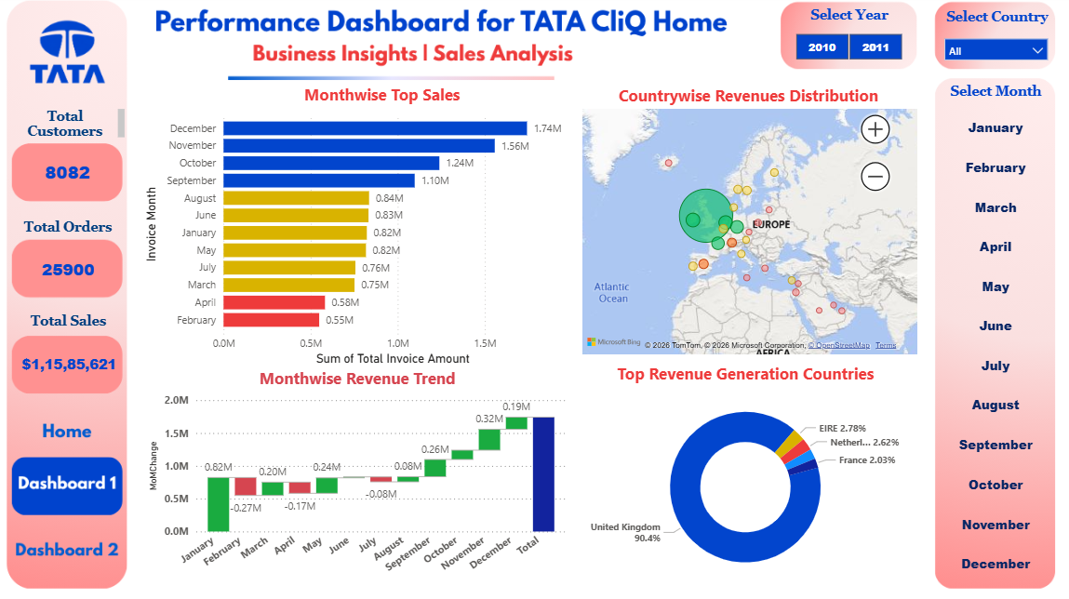
Dashboard 2 — Product Performance
Strong elements:
- Top products by revenue
- Top products by units
- Product tables
- Category-level information
- SKU-level visibility
This is particularly useful for assortment and inventory decisions
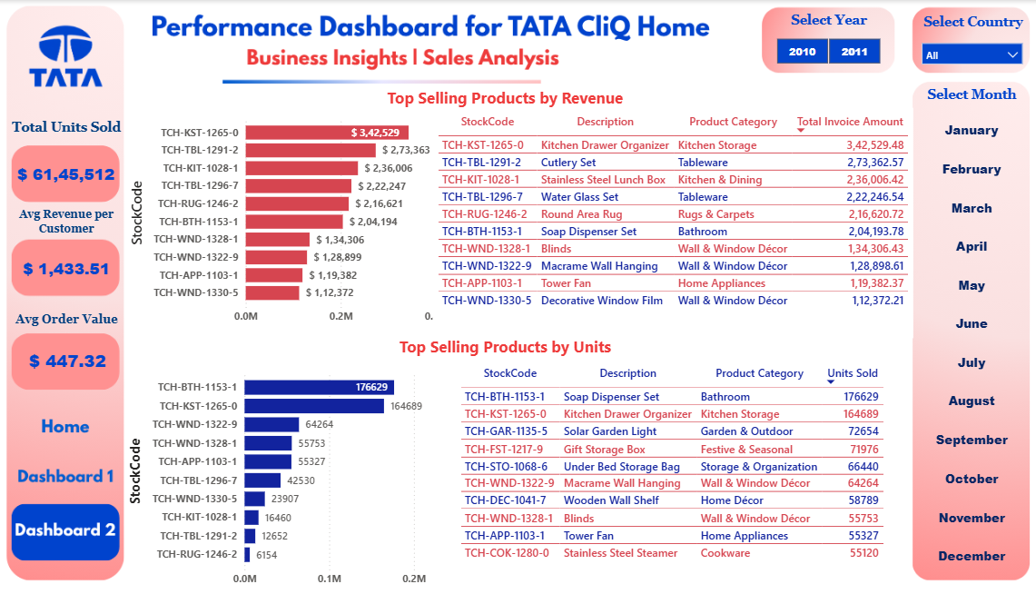
Dashboard 3 — Customer & Retention Analysis
Strong elements:
- Total customer KPI
- Repeat customer KPI
- Repeat customer rate
- Monthwise repeat customer analysis
- Repeat category analysis
- Repeat product analysis
This page effectively communicates customer loyalty and retention behaviour.
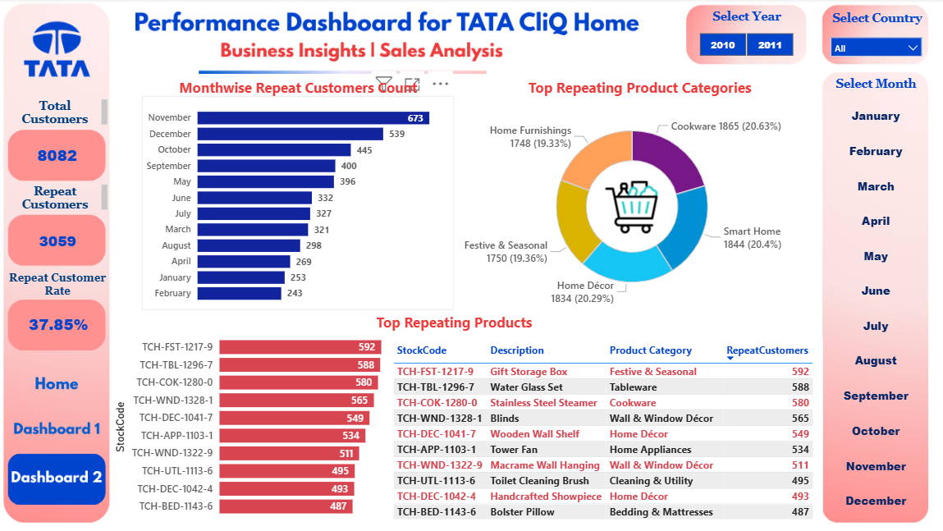
Business Recommendations
- Build a Customer Retention & Loyalty Program
The business should prioritize converting one-time customers into repeat customers.
Given that repeat customers generate approximately 78.27% of revenue, even a modest increase in repeat-customer conversion could create meaningful incremental revenue.
Recommended actions:
- Second-order discount
- Loyalty points
- Personalized product recommendations
- Post-purchase email campaigns
- Replenishment reminders
- Category-based promotions
- Personalized offers for inactive customers

- Prepare Aggressively for the September–December Peak
H2 revenue is approximately 65.94% higher than H1.
Therefore, inventory and marketing should be planned around the seasonal demand curve.
Priority areas:
- Tableware
- Kitchen Storage
- Bathroom
- Home Décor
- Smart Home
- Festive & Seasonal products
Inventory should be secured before September, while marketing campaigns should begin before the demand spike.

- Increase Basket Size Through Cross-Selling & Selective Expansion
The business should create product bundles around high-performing categories.

Examples:
Kitchen Storage + Tableware
Bathroom + Cleaning & Utility
Home Décor + Wall & Window Décor
Cookware + Kitchen & Dining
Home Furnishings + Bedding
At the same time, international expansion should initially focus on markets such as:
- EIRE
- Netherlands
- Germany
- France
rather than attempting broad geographic expansion immediately.
The UK should remain the primary core market while international markets are developed through controlled pilots.

Portfolio Disclaimer: The project should be presented as a portfolio/business intelligence case study and not as an official internal Tata CLiQ management report unless the underlying data and authorization are genuinely official.

**********************************************************************************

